July 18th. 2010
Hi
Well, Kaia is now one year old. I hope you have (or had) a nice birthday party this weekend.

Not much else to write about though a number of things have happened in HK. From time to time, the government has an auction of 'special' number plates. Plates now have alphanumeric characters. e.g. AB1234. In the early days, only numbers were used and those available through de-registration of vehicles, are popular. However, the other day, the number plate '8964' priced at a minimum of $125000 could not be sold. Can you work out why, knowing that most of the buyers would be well-off and perhaps loosely classified as pro-government? Also in HK, after a marathon debate, a minimum wage law was passed, though the rate still has to be decided. Unions are asking for HK$33 per hour while business groups want no more than HK$24 per hour. The figure of $33 is based on the amount needed by a person just to live adequately. Hourly rates for workers in the fast food businesses are among the worst and unions made T-shirts with two 'M's for MacDonald’s 'golden arches' turned 90° to read '33' (can't find a picture of such a T-shirt).
I intended to do less swimming this week but it did not quite work out that way. Although I swam on just three days, I did 10 km and on one of these days I did 4.5 km (which took nearly 2½ hours!). My style also became flatter and so was a bit easier to swim.
The Chief Justice Andrew Li is to retire after 13 years in the job. He was given the job shortly before the handover and has done a good job maintaining a judiciary independent of the government and China. He is a member of the Li clan, Arthur Li being another. However, Andrew Li seems to be the only well-know Li about whom only good things are said.
This past week, a tourist guide was filmed berating tourists from China for not spending enough in a jewellery store. The video ended up on the internet and has been widely viewed in China giving a bad impression of HK as a tourist destination. The problem is with travel agents, especially in China, who offer package tours that are ridiculously cheap and the only way they can make money is from the commissions they receive from sales in selected shops. Similarly, this is the main way the tour guides get paid. Although it is written into the conditions of the tours that participants must spend in the shops, many do not want to. So, the only way to prevent this is to have non-discounted package tours, which may happen.
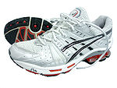
I learnt something interesting the other day from the radio. I suppose you have heard the name of the Japanese sports shoe company "ASICS"? The name is actually an acronym of the Latin phrase "anima sana in corpore sano" which translates to "a sound mind in a sound body".
Another thing I picked up is a potential danger in using credit cards to pay for things by instalments. Apparently, when you do this, the credit card company first pays the business in full so the instalment payments go to the credit card company and not to the business. So, if the business goes bust and you have not received your goods or services, you cannot get any reimbursement from the business and it is the credit card company you are paying and your debt so must be paid in full! In HK recently, some yoga companies have closed down with many clients having agreed to pay thousands of dollars by instalment and so they are now unable to get anything back. So beware.
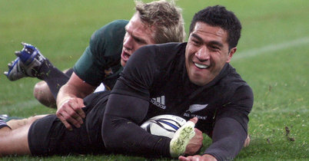
The ABs had a second convincing win over the Springboks, winning by 31-17 in Wellington (and got another bonus point for scoring four tries). The score could easily have been about 43-17 except that Carter missed nearly all of his kicks at goal. The Springboks play the Wallabies next Saturday.
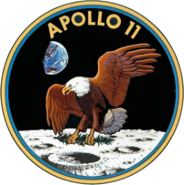
I see from last year's letter, that this time in 1969, the Apollo 11 astronauts were on their way to the moon. The actual lunar landing was on July 20. I know where I was at the time and thought I recalled it very clearly. But maybe not. I thought I had watched the actual landing but as this occurred at 3:17 pm. EST (3 am in HK), this would not be so. Perhaps what I did see was Armstrong stepping onto the Moon’s surface as this would have taken place hours after they actually landed.
That seems to be it for now.
Cheers

